New SafeSport and U.S. Soccer Adult Athlete Requirements Mandatory

Member Club Administrators, due to changes in the U.S. Center for SafeSport and U.S. Soccer Federation policy, athletes 18 or over who may interact with Minor Athletes, have more responsibilities to your Club/CJSA, under state and federal law than they had as a minor.

What does this mean?
Your players that are 18 or 19 or will turn 18 during a current playing season and play on a team with minor athletes (under age of 18) are required to take the SafeSport Core Abuse Prevention training in order to participate. Players who are currently 17 years old may get a head start on this requirement and take the training with parental consent prior to their 18th birthday (see further down this document)

How to manage these requirements:
1. Advise all players and their parents in this age range of the new requirement, and provide them with the Help Guide guide below
- The email address on file for the player and club president will also get an automated message stating that they need to take the training, 30 days prior to birthdate. The player will not be able to take the training until their 18th birthday, UNLESS they follow the instructions below
2. The member organization (town program, club) will be responsible for ensuring athletes that are 18, or 19 or will turn 18 during a current playing season take the SafeSport Core Abuse Prevention training.
- Players will take the SafeSport Core training and upon successful completion will be issued a certificate.
- This certificate must be uploaded to the registration records of the player
- Safesport will be verified only by a district registrar or the state office

SAFESPORT ABUSE PREVENTION
TRAINING Help Guide for Players 18+ - 17 with Parental Consent

Athletes that are 18 or will turn 18 during a current playing season and play on a team with minor athletes must take SafeSport Core Abuse Prevention training. Players who are currently 17 years old may take the training with parental consent.(see further down this document)

• SafeSport is a yearly requirement; the first course is Core training (1.5 hours).
• Adult Athletes that continue to participate and will again be on a team with minor athletes, must complete a refresher course (20 minutes) beginning the year after completing the SafeSport Trained Core training or prior to returning to play (SafeSport training must not expire while playing on a team with minor athletes). If the makeup of a team is such that ALL players are 18 and over and there are NO minors, you do NOT need to complete the training
• If you are a referee and have taken the SafeSport Abuse Prevention 90-minute CORE training, it is the same training and can be approved by your organization.

To create your SafeSport account follow the steps below. If you are 17, you must have parental consent.(see further down this document)

1. Use this link: https://safesporttrained.org?KeyName=JJFAQsQPWNRj01edWcPr - DO NOT POST THIS LINK ON ANY WEBSITE
2. Complete information on the “Sign Up” page.
3. If prompted, log in to the new account you just created.
4. Click on “Menu” and select “Catalog.”
5. Click the Start button for “SafeSport Trained – U.S. Soccer Federation” to complete the course.
6. Download your certificate of completion (directions below). Send to your clubs administrator or designee for upload

Instructions for downloading a certificate of completion are as follows:

1. Please select the “Menu” icon at the top right of your page.
2. Select “Transcript”.
3. Once the transcript page displays, locate the most current completion for the course under the “Certificates” section.
4. Download the certificate by selecting the “Download” button at the right of the completed course.

The player that is 17 years old wishing to take the training earlier than when prompted to, may do so with parental consent.

This consent form below must be completed BEFORE the training is started

Parent consent form - Click Here
After completeing the consent form, follow the directions below

To create your SafeSport account follow the steps below.

1. Use this link: https://safesporttrained.org?KeyName=JJFAQsQPWNRj01edWcPr
2. Complete information on the “Sign Up” page.
3. If prompted, log in to the new account you just created.
4. Click on “Menu” and select “Catalog.”
5. Click the Start button for “SafeSport Trained – U.S. Soccer Federation” to complete the course.
6. Download your certificate of completion (directions below). Send to your clubs administrator or designee for upload

Instructions for downloading a certificate of completion are as follows:

1. Please select the “Menu” icon at the top right of your page.
2. Select “Transcript”.
3. Once the transcript page displays, locate the most current completion for the course under the “Certificates” section.
4. Download the certificate by selecting the “Download” button at the right of the completed course.

Below are step by step instructions with images

Use this link: https://safesporttrained.org?KeyName=JJFAQsQPWNRj01edWcPr

SETUP ACCOUNT
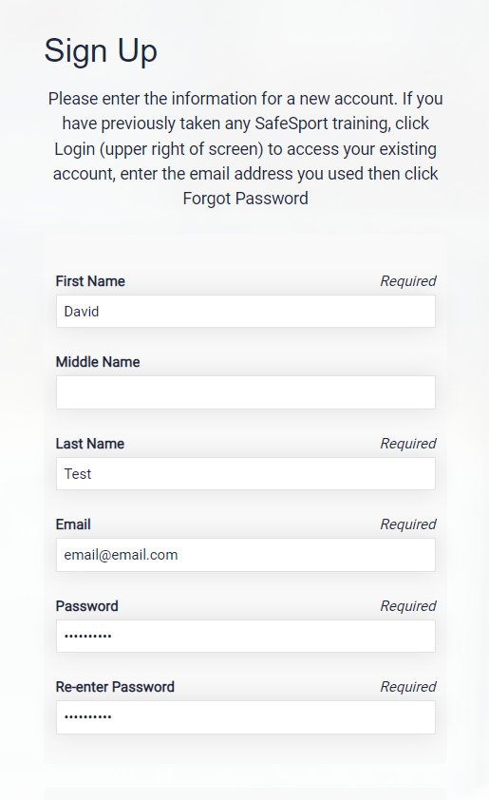

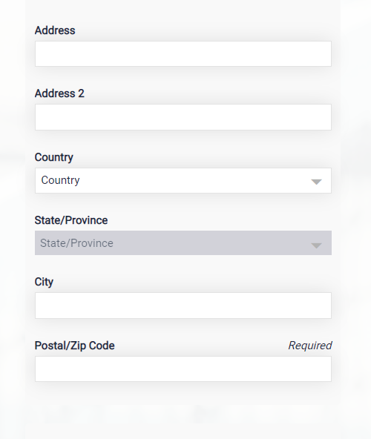

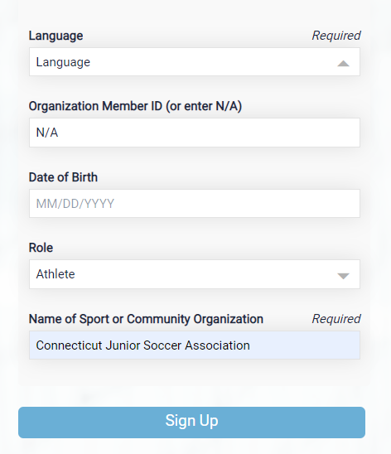

Click “SIGN UP”

PAUSE - Don’t click anything as it sets up your dashboard, it will refresh automatically.

Next agree to terms and conditions (below)

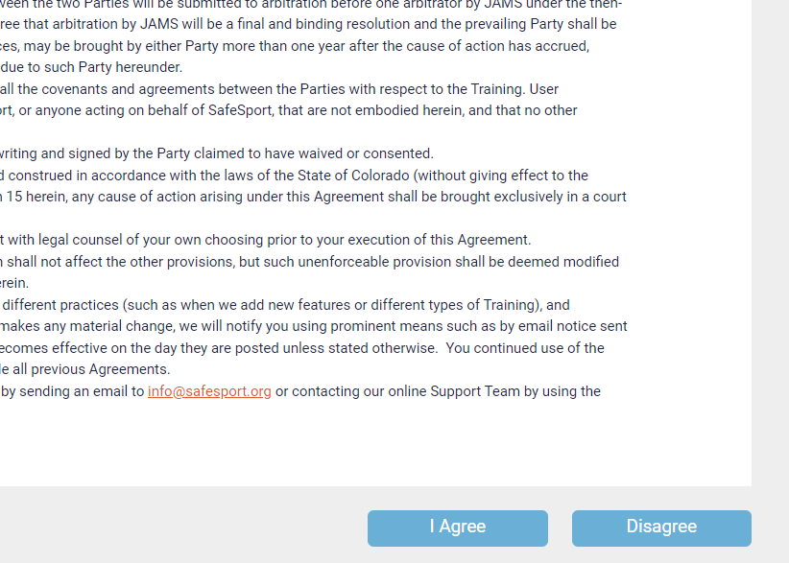

Once into the dashboard, click “CATALOG”

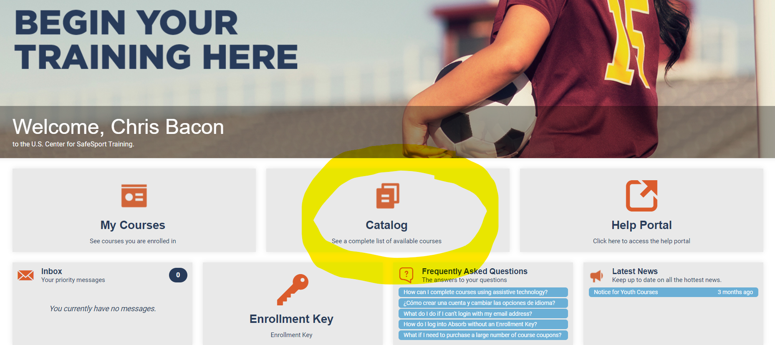

Click on the “start button” underneath the course named “SafeSport Trained - U.S. Soccer Federation”

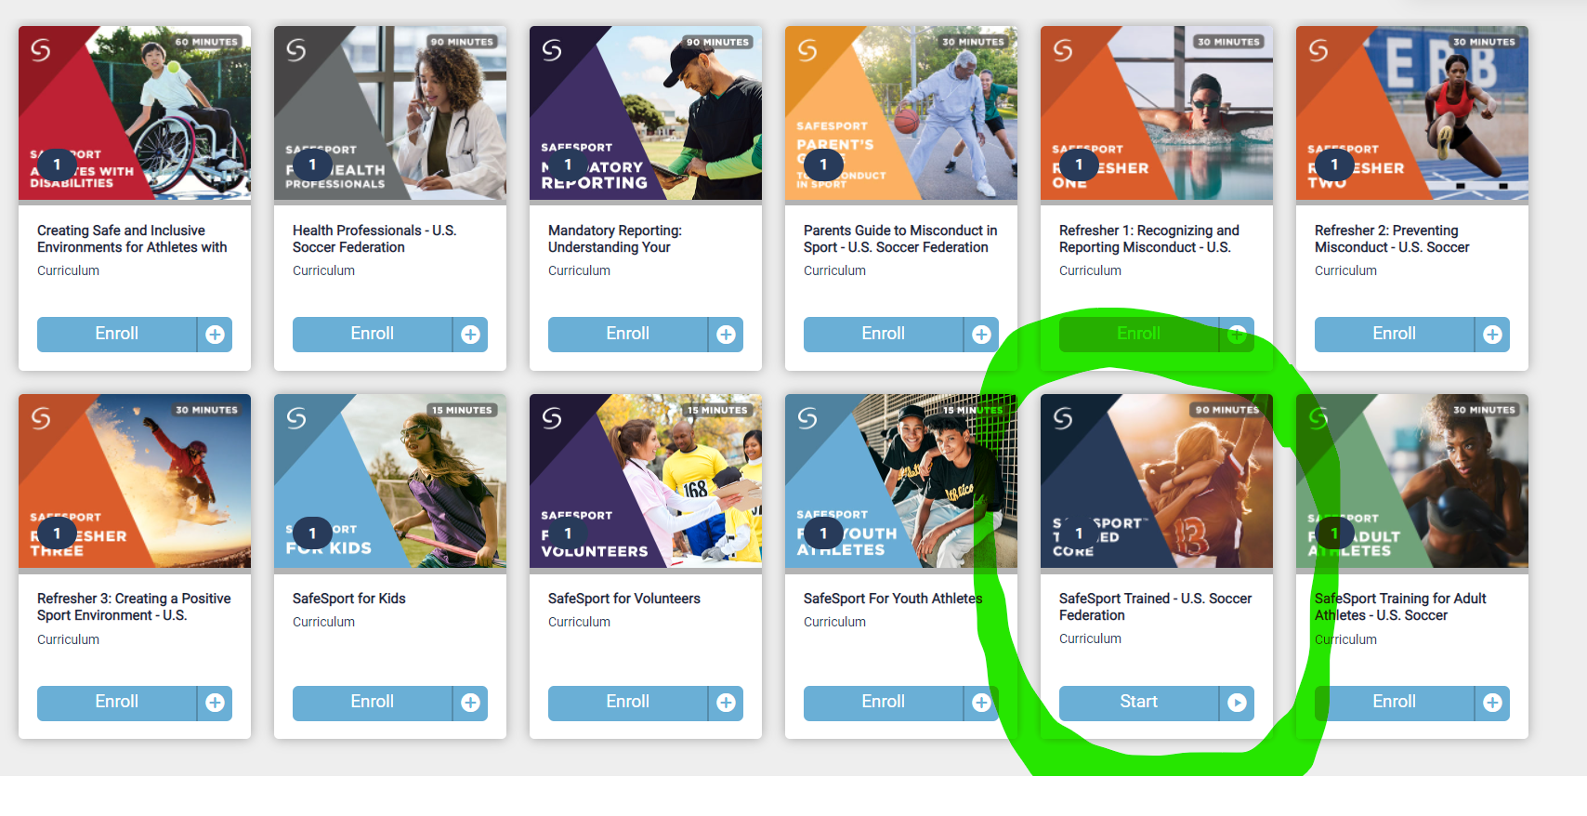
Complete the initial 90 Minute course

Once completed
Instructions for downloading a certificate of completion are as follows:

1. Please select the “Menu” icon at the top right of your page.
2. Select “Transcript”.
3. Once the transcript page displays, locate the most current completion for the course under the “Certificates” section.
4. Download the certificate by selecting the “Download” button at the right of the completed course.

Once downloaded
- This certificate must be presented to the clubs Registrar or other person designated by the organization for upload. Should a club need assistance in uploading you can email certificate to office@cjsa.org
- Safesport will be verified only by a district registrar or the state office

